2018 3과제 Secret Challenges

Floating route

Router2)

Router2(config)# ip route 0.0.0.0 0.0.0.0 204.14.0.21

Router2(config)# ip route 0.0.0.0 0.0.0.0 204.14.0.25 2

Router4)

Router4(config)# ip route 204.14.0.28 255.255.255.252 204.14.0.22

Router4(config)# ip route 204.14.0.28 255.255.255.252 204.14.0.26 2

Rrouter13)

Router13(config)# ip route 10.127.30.128 255.255.255.192 10.0.0.2

Router13(config)# ip route 10.127.30.128 255.255.255.192 10.0.0.6 2

Router12)

Router12(config)# ip route 0.0.0.0 0.0.0.0 10.0.0.1

Router12(config)# ip route 0.0.0.0 0.0.0.0 10.0.0.5 2

Full-Routing

Router0)

Router0(config)# router eigrp 200

Router0(config-router)# network 204.14.0.16 0.0.0.3

Router0(config-router)# network 204.14.0.8 0.0.0.3

Router1)

Router1(config)# router eigrp 200

Router1(config-router)# network 204.14.0.8 0.0.0.3

Router1(config-router)# router ospf 1

Router1(config-router)# network 204.14.0.1 0.0.0.0 area 0

Router4)

Router4(config)# router eigrp 200

Router4(config-router)# network 204.14.0.16 0.0.0.3

Router14)

Router14(config)# router ospf 1

Router14(config-router)# network 204.14.0.2 0.0.0.0 area 0

Router14(config-router)# network 112.36.0.13 0.0.0.0 area 0

Router6)

Router6(config)# router ospf 1

Router6(config-router)# network 112.36.0.14 0.0.0.0 area 0

Router6(config-router)# network 112.36.0.9 0.0.0.0 area 0

Router6(config-router)# network 112.36.0.18 0.0.0.0 area 0

Router17)

Router17(config)# router ospf 1

Router17(config-router)# network 112.36.0.10 0.0.0.0 area 0

Router17(config-router)# network 112.36.0.5 0.0.0.0 area 0

Router17(config-router)# network 112.36.0.5 0.0.0.0 area 0

Router16)

Router16(config)# router ospf 1

Router16(config-router)# network 112.36.0.22 0.0.0.0 area 0

Router16(config-router)# network 112.36.0.6 0.0.0.0 area 0

Router17)

Router17(config)# router ospf 1

Router17(config-router)# network 112.36.0.2 0.0.0.0 area 0

Router10)

Router10(config)# router ospf 1

Router10(config-router)# network 112.36.0.26 0.0.0.0 area 1

Router10(config-router)# network 112.36.0.17 0.0.0.0 area 0

Router10(config-router)# network 112.36.0.21 0.0.0.0 area 0

Router11)

Router11(config)# router ospf 1

Router11(config-router)# network 112.36.0.25 0.0.0.0 area 1

Router11(config-router)# network 112.36.0.29 0.0.0.0 area 1

Router13)

Router13(config)# router ospf 1

Router13(config-router)# network 112.36.0.30 0.0.0.0 area 1

Redistribute

Router1)

Router1(config)#router eigrp 200

Router1(config-router)# redistribute ospf 1 metric 1544 20000 255 1 1500

Router1(config-router)# no auto-summary

Router1(config)# router ospf 1

Router1(config-router)# redistribute eigrp 200 subnets

Router4)

Router4(config)# router eigrp 200

Router4(config-rotuer)# redistribute static metric 100000 10 255 1 1500

Router4(config-router)# redistribute connected metric 1000000 10 255 1 1500

Router0 network summary

Router0)

Router0(config)#interface g0/0

Router0(config-if)#ip summary-address eigrp 200 204.14.0.16 255.255.255.240 5

Router0(config)#interface g0/1

Router0(config-if)#ip summary-address eigrp 200 0.0.0.0 0.0.0.0 5

OSPF STUB AREA

Router10, Router11, Router13

Router(config)#router ospf 1

Router(config-router)#area 1 stub

OSPF Authentication

Router10, Router11, Router13

Router(config)#router ospf 1

Router(config-router)#area 1 authentication message-degrest

Router10)

Router10(config)#interface s0/1/1

Router10(config-if)#ip ospf meeage-digrest-key 1 md5 cisco

Router11)

Router11(config)#interface g0/0

Router11(config-if)#ip ospf message-degest-key 1 md5 cisco

Router11(config)#interface s0/2/0

Router11(config-if)#ip ospf message-degest-key 1 md5 cisco

Router13)

Router13(config)#interface g0/0

Router13(config-if)#ip ospf message-degest-key 1 md5 cisco

Etherchannel

Switch0)

Switch0(config)#interface range fastEthernet 0/3-4

Switch0(config-if-range)#channel-group 1 mode desirable

Switch1)

Switch1(config)#interface range fastEthernet 0/2-3

Switch1(config-if-range)#channel-group 1 mode desirable

VLAN

Switch0, Switch1

Switch(config)#vlan 10

Switch(config)#vlan 20

Switch0)

Switch0(config)#interface g0/1

Switch0(config-if)#switchport mode trunk

Switch0(config)#interface port-channel 1

Switch0(config-if)#switchport mode trunk

Switch1)

Switch1(config)#interface port-channel 1

Switch1(config-if)#switchport mode trunk

PAT

Router3)

Router3(config)#ip nat inside source list ZERONET interface gigabitEthernet 0/0 overload

Router3(config)#ip access-list standard ZERONET

Router3(config-std-nacl)#permit 10.127.30.64 0.0.0.63

Router7)

Router7(config)#ip nat inside source list INSIDE interface gigabitEthernet 0/0 overload

Router7(config)# ip access-list standard INSIDE

Router7(config-std-nacl)# permit 10.127.30.192 0.0.0.63

Router13)

Router13(config)#ip nat inside source list DS_NET interface GigabiEthernet0/0 overload

Router13(config)# ip access-list standard DS_NET

Router13(config-std-nacl)# permit 10.127.30.128 0.0.0.63

Router13(config-std-nacl)# permit 10.0.0.0 0.0.0.3

Router13(config-std-nacl)# permit 10.0.0.4 0.0.0.3

Port-forwarding

Router3)

Router3(config)# ip nat inside source static tcp 10.127.30.66 80 204.14.0.30 80

Router3(config)# ip nat inside source static tcp 10.127.30.65 2000 204.14.0.30 2000

Router3(config)# ip nat inside source static udp 10.127.30.66 1645 204.14.0.30 1645

Router7)

Router7(config)# ip nat inside source static udp 10.127.30.193 123 112.36.0.2 123

Router7(config)# ip nat inside source static udp 10.127.30.193 53 112.36.0.2 53

Router13)

Router13(config)# ip nat inside source static tcp 10.127.30.130 80 112.36.0.30 80

Router13(config)# ip nat inside source static tcp 10.127.30.129 1720 112.36.0.30 1720

NTP

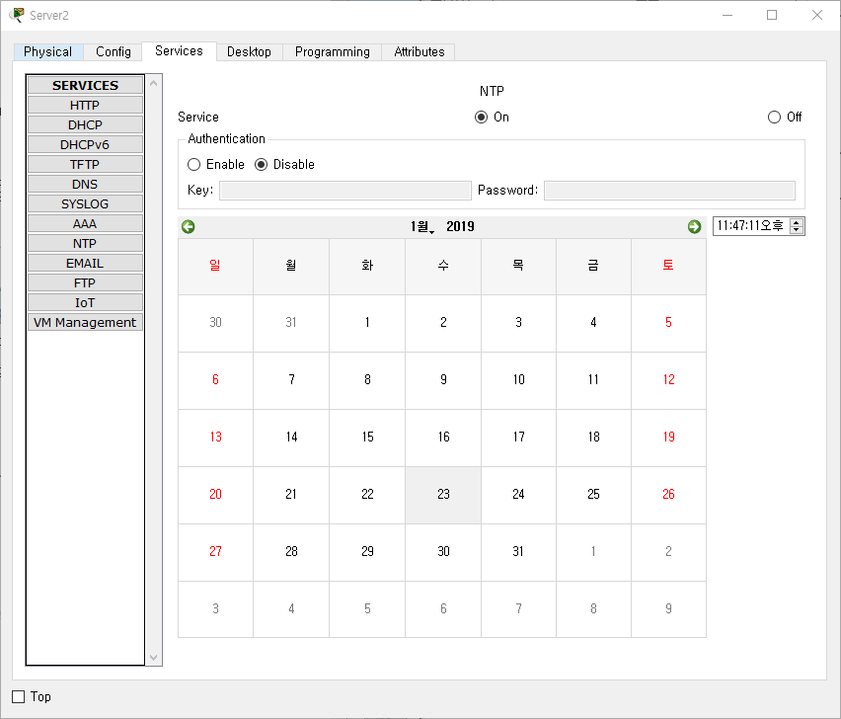

모든 라우터에서 ntp server 설정

Router(config)#ntp server 112.36.0.2

DHCP

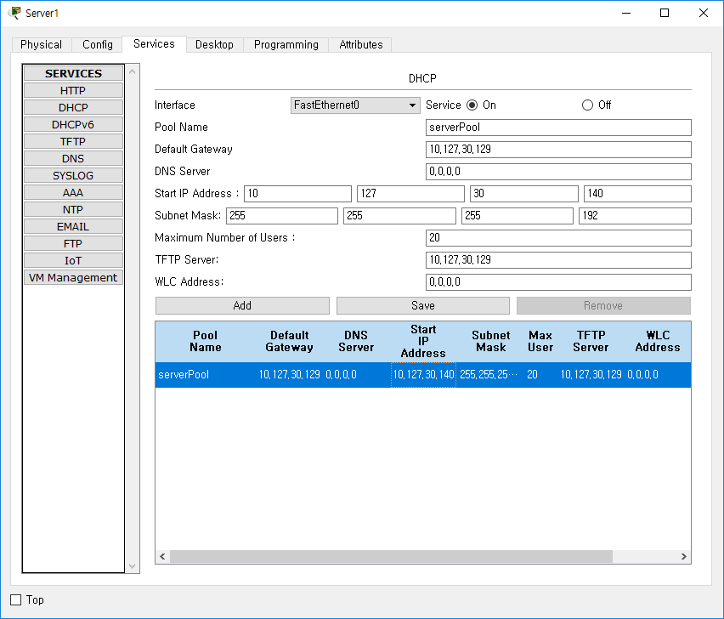

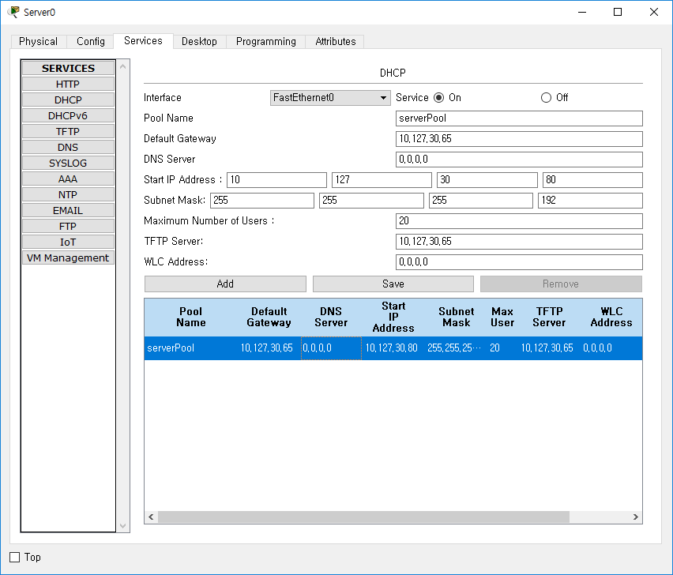

AAA

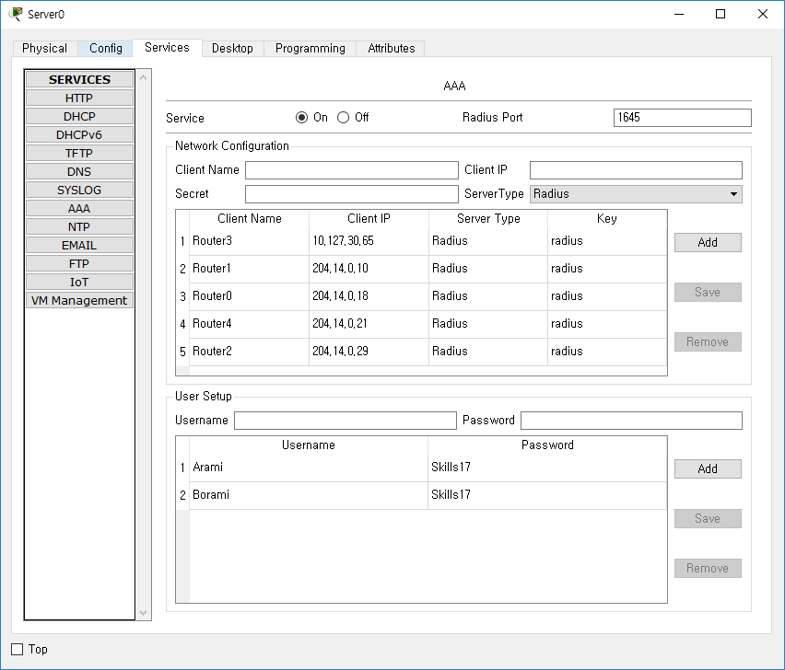

콘솔 보안

Router0~4

Router(config)#aaa new-model

Router(config)#aaa authentication login aaa group radius

Router(config)#radius-server host 10.127.30.66 auth-port 1645 key radius

Router(config)#line con 0

Router(config-line)#login authentication aaa

Access Point

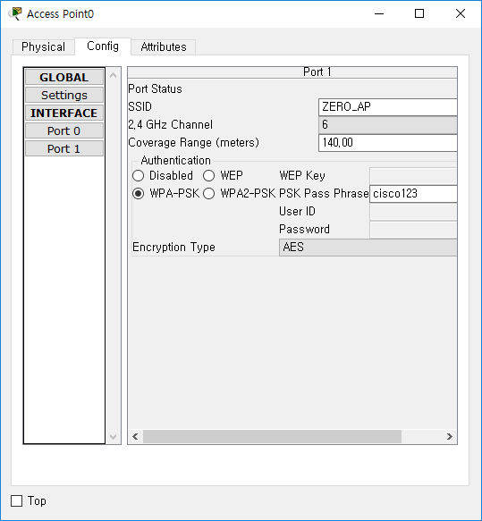

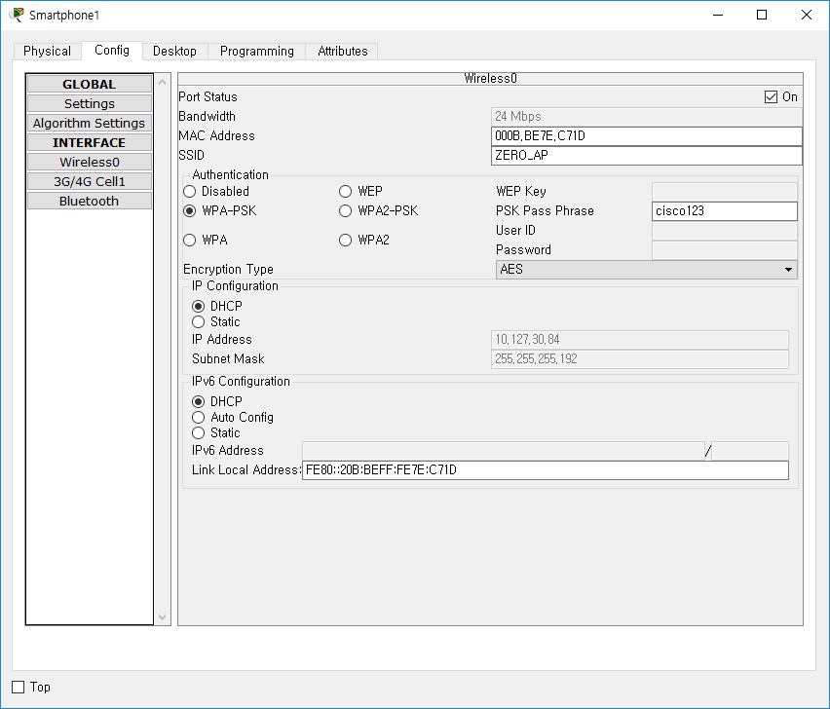

설정후 클라이언트에서 주소를 다시 받아와야함

VOIP

Router3, Router12

Router(config)#license boot module c2900 technology-package uck9

Router(config)#do wr

Router(config)#do reload

Router3)

Router3(config)# telephony-service

Router3(config-telephony)# max-ephones 1

Router3(config-telephony)# max-dn 1

Router3(config-telephony)# ip source-address 10.127.30.65 port 2000

Router3(config-telephony)# auto assign 1 to 1

Router3(config)#ephone 1

Router3(config-ephone)# type 7960

Router3(config)#ephone-dn 1

Router3(config-ephone-dn)#number 1001

Router3(config)#dial-peer voice 2001 voip

Router3(config-dial-peer)#destination-pattern 2001

Router3(config-dial-peer)#session target ipv4:112.36.0.30

Router12)

Router12)

Router12(config)# telephony-service

Router12(config-telephony)# max-ephones 1

Router12(config-telephony)# max-dn 1

Router12(config-telephony)# ip source-address 10.127.30.129 port 2000

Router12(config-telephony)# auto assign 1 to 1

Router12(config)#ephone 1

Router12(config-ephone)# type 7960

Router12(config)#ephone-dn 1

Router12(config-ephone-dn)#number 2001

Router12(config)#dial-peer voice 1001 voip

Router12(config-dial-peer)#destination-pattern 1001

Router12(config-dial-peer)#session target ipv4:204.14.0.30

